Instructions

This survey on attitudes towards absentee voting is six-pages-long, but is straightforward and simple to answer. It includes primarily simple “yes” or “no” questions, as well as multiple choice questions. There are also a limited number of open ended questions.

To check the box that corresponds to your answer, (1) double click the box () of your choice. When the little dialogue box appears, Look for default Value, click on the circle near “checked” and then “ok” (see image below).

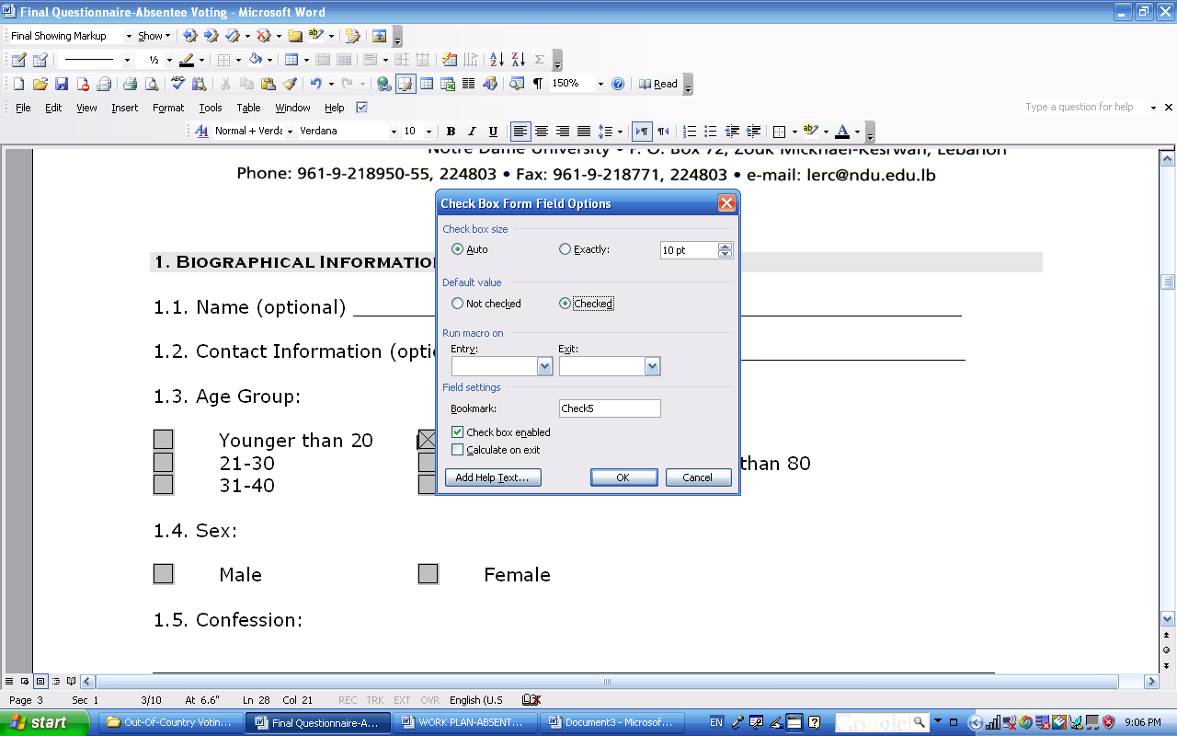

Section 1

1.1. Name (optional) ____________________________________________________

1.2. Contact Information (optional):

Street Address:

Email Address:

Telephone Number:

1.3. Age Group:

17-20 41-50 71-80
21-30 51-60 Older than 80
31-40 61-70

1.4 How many years have you spent abroad?

1-5 years 16-20 years 31-35 years
6-10 years 21-25 years 36-40 years
11-15 years 26-30 years 41+ years

1.5. Sex:

Male Female

1.6. There are many confessional communities in Lebanon which make up the rich diversity of the country. This is not a confessional question, but rather a realistic and normal question to understand how migration is affecting the different communities in Lebanon.

What is your confession; please select an answer from the following:

Maronite Chaldean
Greek Orthodox Protestant
Greek Catholic Sunnite
Armenian Orthodox Shiite
Armenian Catholic Assyrian
Druze Other, please specify______________

1.7. Do you currently have Lebanese citizenship?

Yes No

1.8. If yes, do you have the new Lebanese passport?

Yes No

1.9. If yes, is your passport still valid in 2009?

Yes No

1.10. Do you have the new Lebanese I.D. card issued as of 1994?

Yes No

1.11. Were you born in Lebanon?

Yes No

1.12. If yes, in which village, Mohafaza (Governorate), were you born in?

___________________________________________________________________________

1.13. Was your father born in Lebanon?

Yes No

1.14. If you were not born in Lebanon, when did your Lebanese family members emigrate from Lebanon?
___________________________________________________________________

1.15. If you have Lebanese citizenship, are you registered as a voter in your district of birth?

Yes No Not applicable

1.16. If you are registered as a voter, have you ever transferred your voter registration to another district?

Yes No Not applicable

1.17. If yes, to which village, mohafaza, governorate did you transfer your voter registration?

___________________________________________________________________

1.18. What is/are your current country(ies) of residence?

___________________________________________________________________

1.19. Do you have the nationality of your country(ies) of residence?

Yes No

1.20. What is your marital status?

Married
Single,
Never married
Widowed
Separated
Divorced

1.21. If you are/were married, is/was your spouse Lebanese or of Lebanese origin (origin or descent? Is there a difference between both? If not then make it consistent throughout the survey)?

Yes No

1.22. Do you speak Arabic?

Yes No

1.23. If yes, please determine your fluency level:

Excellent
Good
Fair

1.24. Do you read Arabic?

Yes No

1.25. If yes, determine your skill level:

Excellent
Good
Fair

1.26. Do you write Arabic?

Yes No

1.27. If yes, determine your skill level:

Excellent
Good
Fair

1.28. Do you have children?

Yes No

1.29. If yes, please specify their number, age, and gender. (Please put [M] for male and [F] for female), speak Arabic (please put [Y] for yes and [N] for No), nationality of the children (please put [Y] for yes and [N] for No).

Number of children | Age | Gender | Speak Arabic | Are they registered as Lebanese

1.30. Which of the following represents the highest level of education that you have completed?

Partial secondary school education or less
High school graduate
Bachelor degree
Masters Degree
Terminal university degree (doctorate or equivalent)
Post-graduate training

Section 2

2.1. Are you currently employed?

Yes No

2.2. If yes, please select your current area of employment:

A diasporic organization
An intergovernmental organization
An international organization
A government institution representing your country of residence
A government institution representing your sending country
An NGO/Non-profit organization
An academic initiative
A business/practice
A family business
Others, please specify____________________

2.3. If you are working full-time for a diasporic organization, what is the name and location (s) of the diasporic organization? (Optional).

_________________________________________________________________________

2.4. If you are not employed by or the leader of a diasporic organization, are you an active member of any diasporic organization (e.g. Lebanese village association, Lebanese cultural association, Lebanese political party offices in the diaspora…)

Yes No

2.5. If yes, is the organization (you may tick more than one):

A cultural association
A political association
A development association
A financial institution
A religious association
A village association
A research center
An academic/educational institution
A chamber of commerce
Other (Please specify: _________________________________________________)

2.6. What is your role within the organization (you may tick more than one)?

I send donations
I participate in the activities set up by the organizations
I volunteer my time as an organizer

2.7. If you volunteer your time at the organization, is it:

Few times a week Few times a month Few times a year

2.8. Does the organization you are involved with have other offices in other countries?

Yes No

2.9. If yes, how many offices are there approximately? And where?

__________________________________________________________________________

Section 3

3.1. How often do you visit Lebanon?

Very often From time to time Never

3.2. If you visit Lebanon, when was your last visit to Lebanon?
___________________________________________________________________________

3.3. Do you actively follow the Lebanese news?

Yes No

3.4. If yes, how often:

Very often From time to time

3.5. If you follow the Lebanese news, what is the medium you use (you may tick more than one):

Print version of Lebanese newspapers and/or magazines
Online Lebanese newspapers and/or magazines
Online news bulletins and discussion groups
Lebanese satellite TV channels
Others, please specify_________________________________

Section 4

4.1. If you are eligible to vote, did you vote during the 2005 Lebanese parliamentary elections?

Yes No Not applicable

4.2. If you voted during the 2005 Lebanese parliamentary elections, what were your main reasons for voting?

________________________________________________________________________________________________________________________________________________________________

4.3. If you did not vote during the 2005 parliamentary elections, what were your main reasons for not voting?

________________________________________________________________________________________________________________________________________________________________________________________________________________________________________________

4.4. Did you help organize trips of Lebanese emigrants wishing to vote during the 2005 Lebanese elections?

Yes No Not applicable

4.5. If you are eligible to vote, would you be willing to travel to Lebanon to vote in the 2009 parliamentary election?

Yes No Not applicable

4.6. If yes, are you able to finance your trip to Lebanon yourself?

Yes No Not applicable

4.7. If the Lebanese government approves out-of-country voting, would you like to vote in the 2009 parliamentary election from your country of residence?

Yes No Not applicable

4.8. If yes, would you be willing to vote at an embassy or consulate in your country of residence (e.g. The Lebanese Embassy or Consulate in Australia)?

Yes No Not applicable

4.9. If yes, but the embassy or consulate is located several hundred kilometers away, would you be willing to invest the necessary travel time and money needed to vote there?

Yes No Not applicable

4.10. If available and you had the opportunity to vote by post, would you vote in the 2009 Lebanese elections?

Yes No Not applicable
4.11. If available and you had the opportunity to vote by e-mail, would you vote in the 2009 Lebanese elections?

Yes No Not applicable

4.12. Whether you are eligible to vote or not, below is a list of arguments usually used in support of out-of-country voting. Please rate each argument according to whether you think it is extremely important, somewhat important, neutral, not very important, or not at all important.

ARGUMENT | EXTREMELY IMPORTANT | SOMEWHAT IMPORTANT | NEUTRAL | NOT VERY IMPORTANT | NOT AT ALL IMPORTANT
Lebanese emigrants make great contributions to Lebanon and must be able to have a say in how the country is governed

Lebanese emigrants are Lebanese citizens and must have the right to vote

Lebanese residents are not making good voting choices (e.g. you think they are subject to vote-buying…)

Lebanese residents do not have a true grasp of international politics and are making choices with severe international political consequences

It is not practical for you to travel to Lebanon during election time

The position of the political party or community you are member of is in favor of out-of-country voting

Out-of-country voting is necessary for the political survival of your community in Lebanon

Out-of-country voting will allow you to vote for the candidate who will create favorable investment opportunities for Lebanese emigrants

4.13. Whether you are eligible to vote or not, below is a list of arguments usually used in contra of out-of-country voting. Please rate each argument according to whether you think it is extremely important, somewhat important, neutral, not very important, or not at all important in determining your opinion regarding out-of-country voting:

ARGUMENT | EXTREMELY IMPORTANT | SOMEWHAT IMPORTANT | NEUTRAL | NOT VERY IMPORTANT | NOT AT ALL IMPORTANT
Lebanese emigrants do not pay taxes in Lebanon (unless they have investments in Lebanon) and therefore should not have the right to vote

Most Lebanese emigrants have lost their Lebanese citizenship

Developing an out-country-voting mechanism is not cost-effective

Lebanese emigrants are not making good voting choices (e.g. you think they are influenced by the foreign policies of the countries they are residing in)

Lebanese emigrants are not aware of local Lebanese politics and their votes will have negative consequences for Lebanese residents

You do not mind traveling to Lebanon during election time

The position of the political party or community that you are part of is not in favor of out-of-country voting

Out-of-country voting is harmful for the political survival of your community in Lebanon

Section 5

5.1. Does the Lebanese diplomatic mission (embassy or consulate) in your country of residence have a website?

Yes No I do not know

5.2. If yes, how often do you visit the website?

Never Sometimes Often

5.3. Is the website regularly updated?

Yes No

5.4. Are you satisfied with the content of the website?

EXTREMELY SATISFIED | SOMEWHAT SATISFIED | NEUTRAL | NOT VERY SATISFIED | NOT AT ALL SATISFIED

5.5. Do you receive post or emails from the Lebanese diplomatic mission in your country of residence?

Yes No

5.6. Do you receive post or emails from the Lebanese diplomatic mission in your country of residence informing you of election dates in Lebanon?

Yes No

5.7. Does the embassy organize events (cultural, social, political, economic…) for Lebanese in your country of residence?

 | Very Often | Often | Sometimes | Never
Cultural Events
Social Events

Political Events

Events with a financial aspect

5.8. How would you rate your relationship with the Lebanese diplomatic mission in your country of residence?

THE BEST | BETTER THAN AVERAGE | NEUTRAL | AVERAGE | NEEDS IMPROVEMENT

5.9. How efficient is your embassy in processing your requests?

HIGHLY EFFICIENT | SOMEWHAT EFFICIENT | INEFFICIENT | NOT APPLICABLE

5.10. Do you think that it is important that the embassy maintains neutrality?

Yes No

5.11. If yes, which measures should be taken to ensure neutrality (you may tick more than one)?

Ensure confessional balance among embassy staff
Instill transparency and monitoring of embassy activities
Ensure regular rotation of the ambassador and embassy staff
Ensure a verifiable complaints system

THANK YOU FOR HELPING US WITH THIS PROJECT

(Kindly return the duly filled questionnaire to the Lebanese Emigration Research Center researcher mltayah@ndu.edu.lb and babdelkhalek@ndu.edu.lb).

